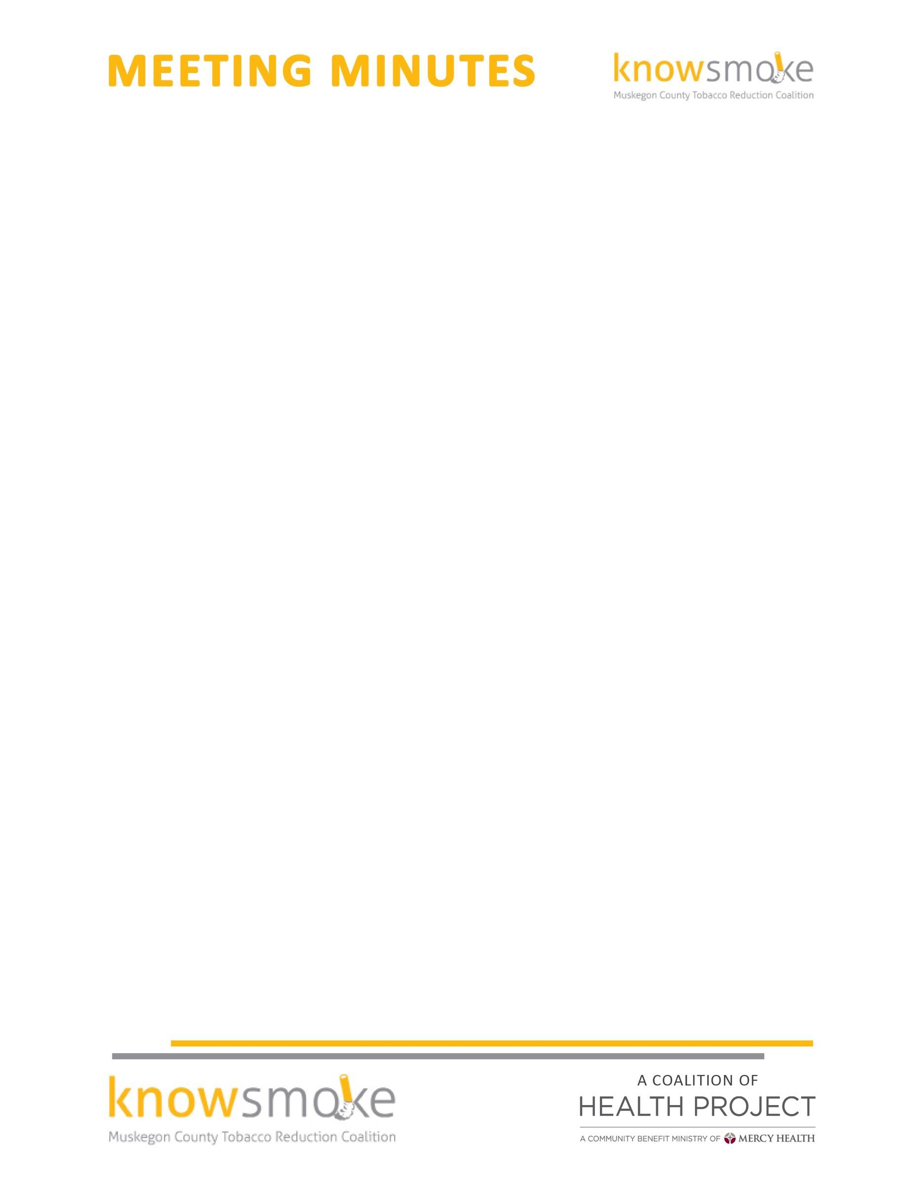

MEETING TITLE: Knowsmoke Coalition
DATE & TIME: March 27, 2017 9:30 a.m. – 11:00 a.m.

ATTENDEES: Cyndi Powers(MCHP); Rachel McCoy(MCHP);Missy Gallegos(Public Health); Roger Starring(GE Aviation); Cinti Mwagu(Public Health); Joel Jarvis(1in21);Aimee Taylor(Mercy Health)

Welcome and Introductions -- Missy called the meeting to order at 9:07
Approval of Minutes – February minutes were approved by all members

Kick Butts Day- YAC student's event update: On March 8, coalition member along with the Youth Advisory Committee (YAC) supported a T21 educational event at Muskegon High School that helped the youth educate their peers on tobacco use and abuse. On March 15 the Muskegon HS students were asked to sign a banner that supports them on the T21 and will be used at future T21 efforts. Students were asked to sign a letter that will be sent to directors of Disney movies to say they do not support smoking in Disney movies.

MAMDP- Tobacco Take Back Event- Members of the MAMDP coalition agreed to add 2 questions about a future Tobacco take back event onto their current medication take back survey. The questions added are as follows: 1. Are you a current smoker? 2. Would you like future take back events to accept unused/unwanted tobacco products? Survey results will be shared after the next take back event.

Tobacco 21 Initiative Update- Revel developed the new Muskegon Tobacco 21 logo and this was used on the banner for the Kick Butts Day event and will be used for future T21 activities.

Social Media Committee Update- Rachel and Aimee continue to post on the Knowsmoke FB page. The pictures of the Kick Butts Day Events have been posted. Ideas were discussed with the group on how to move forward with social media and communication efforts to advertise for the 2017 Knowsmoke Zombie Walk.

Knowsmoke Budget- The Knowsmoke budget needs to be spent by June 30, 2017. Coalition members discussed purchasing items such as: Table cover for outreach events, display board of coalition info, smoke free give always, and partnering with MFC & Public health to bring in a Brief Action Planning speaker to educate the CHWs and MFC employees and others.

Other good and welfare – In June the Chair position will be up for nomination. Missy Gallegos has been the chair for the Knowsmoke Coalition for the past year and has done a phenomenal job. We will miss her as our chairperson but will continue to have her as a member of the Knowsmoke Coalition. Please send new chair suggestions to Cyndi or Missy to be discussed at the meeting in April.

Next Meeting: April 24, 2017 at 9:30am -10:30am the Coffee Factory

