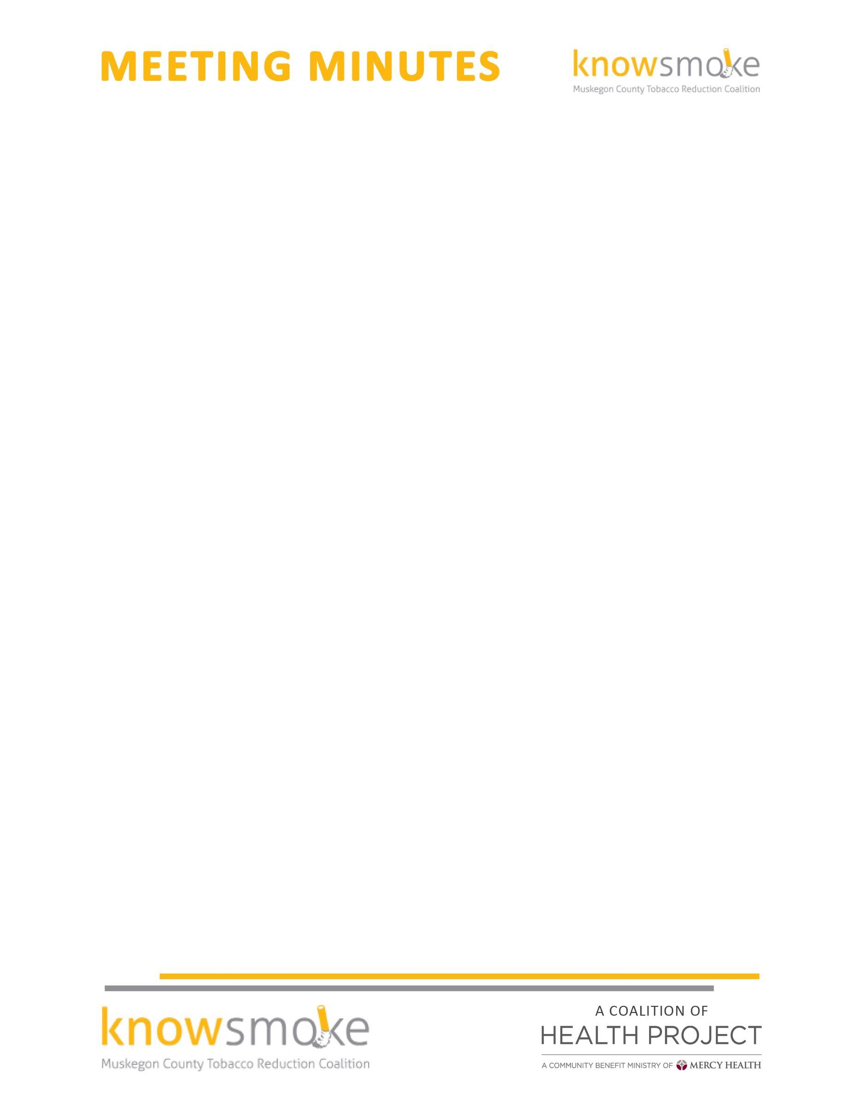

MEETING TITLE: Knowsmoke Coalition
DATE & TIME: May 22, 2017 9:30 a.m. – 11:00 a.m.

ATTENDEES: Cyndi Powers(MCHP); Rachel McCoy(MCHP); Cinti Mwagu(Public Health); Aimee Taylor(Mercy Health);Melisa Dove(MFC);Joy Evans(HCC); Missy Gallegos(Public Health)

Welcome and Introductions -- Missy called the meeting to order at 9:05
Approval of Minutes –Missy approved the April minutes

MAMDP-Coalition members review the MAMDP survey that asked if the community would like future take back events that accept unused or unwanted tobacco products; such as, cigarettes, cigars, chewing tobacco, e-cigs,
e-cigs batteries, lighters, etc. and 58% said yes. Coalition members felt more surveys should be conducted in our community. Aimee Taylor suggested Pride events. Another event mentioned was the Muskegon Heights Festival in the Park that takes place on June 17th and the annual Diabetes Conference on November 4, 2017. Cyndi will coordinate with Mimi Rankin to ensure the coalition will get a vendor table. Missy offered to create a 2 question survey for coalition members to use at these events. Cyndi will coordinate a conference call with the coalition who conducted a take back event and invite members. Members suggested that we could piggy back with the Countywide Household Hazardous Recycle event and if this is not available, we will host our own event possibly with the World No Tobacco Day! It was discussed to support the "No Menthol Sunday" where coalition members could advertise the take back event if Knowsmoke does it as a standalone. The use of social media was brought up to advertise the event. Examples given were (media contest).

As an extension of the conversation promotional items were brought up to help advertise for the event with Knowsmoke’s logo. They also suggested reaching out to the American Lung Association to ask for free promotional items.

June 19th Meeting- Talked to coalition members about the details for the event (food, # registered, speaker, and Knowsmoke having a table to promote coalition.) Members agreed to write a 3 to 5 sentence paragraph on how being part of Knowsmoke has helped them in their efforts to reduce tobacco use and what resources they provide to their members/clients. This is due to Missy Gallegos by June 8^{th.}

Social Media Committee Update- Pre- scheduled posts to provide education on No Menthol Sunday and World No Tobacco Day will post soon. Cyndi asked media committee if they would be willing to work on creating a campaign to launch the Tobacco Take Back event, schedule posts or conduct the media activity.

Other Good and Welfare-
Zombie Walk-Date was chosen for Saturday, October 14^{th,} 2017 same time as last year. Idea for sponsorships were discussed. Members suggested meeting to further discuss and assign roles for members to help seek sponsorships. Suggested time frame was after June 19th. Missy offered to revise the new sponsorship letter used in previous years and will be mailed out to members.

Next Meeting: June 19, 2017 at 9:30am -11:00am @ the Muskegon Lakeshore Chamber of Commerce, 380 W Western Ave, Muskegon, MI 49440

