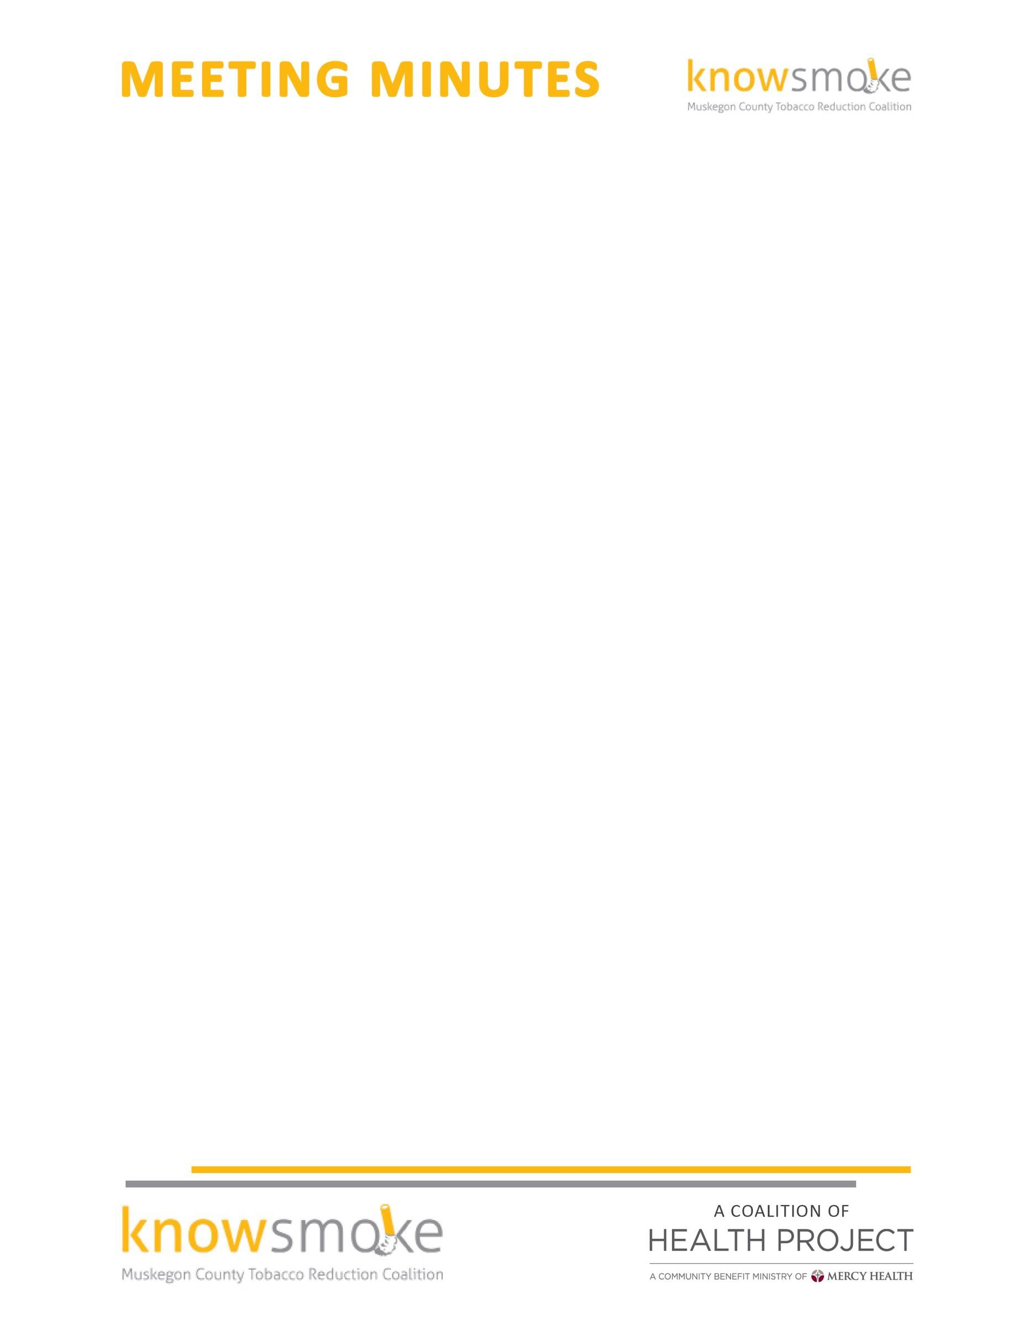

MEETING TITLE: Knowsmoke Coalition
DATE & TIME: January 23, 2016 9:00 a.m. – 10:00 a.m.

ATTENDEES: Cyndi Powers(MCHP); Rachel McCoy(MCHP); Joel Jarvis(1in21);Amy Forward(Access Health);Missy Gallegos(Public Health); Melissa Dove(MFC);Laura Fitzpatrick(MCHP)

Welcome and Introductions -- Missy called the meeting to order at 9:10
Approval of Minutes -- November minutes were approved by all members

Knowsmoke 2016-2017 Budget Review -- The quarterly budget for July 1-June 1, 2017 was discussed and approved by all members present. Funds will be used to support Knowsmoke activities for this period. It was also suggested that the coalition designate a portion of the funds that will go toward an overall DFC innovation that will tie substance abuse messaging for youth that a single message that all coalitions under DFC can use. The group agreed to support this effort going forward.

Knowsmoke Work Plan Update –The 2017 Workplan was presented to the members that the tobacco reduction activities are currently aligning for the quarterly period July 1-June 1, 2017.

Tobacco 21 Initiative Update- Cyndi Powers presented an update around the Tobacco 21 Resolution of support. A presentation was delivered at the county commissioner's subcommittee meeting and then again at the monthly county commissioners meeting. A Resolution of Support was introduced and accepted by commissioners. Cyndi will keep the initiative moving with a survey of business owners, adults, and youth to show local support.

The Tobacco 21 activity surrounding the youth was discussed that the coalition members will continue to work w the Youth Advisory Committee to educate youth in the HS that currently have YAC groups.

It was also discussed to possibly have a sign up where community members can support Tobacco 21 at the Oral Coalition Health Fair at Muskegon Mall on February 11, 2017. Educational materials will be available.

Social Media Committee Update – Rachel requested that her and Aimee Taylor come up with a content calendar and a strategy on how to reply to negative FB posts surrounding upcoming T21 Facebook ads.

Other good and welfare – Cyndi reported that she has Freedom from Smoking classes scheduled for Resilience month with no participants who have signed up. Efforts were discussed with coalition members that also teach smoking cessation on how to get more participation. Missy would like to pull together a meeting on all Tobacco Specialist on community needs.

Providers - Missy mentioned there was a request from a group of providers that would like training in Motivational Interviewing and a presentation on the Tobacco Pathway.

Next Meeting: February 27, 2017 at 9:30am -10:30am The Coffee Factory

