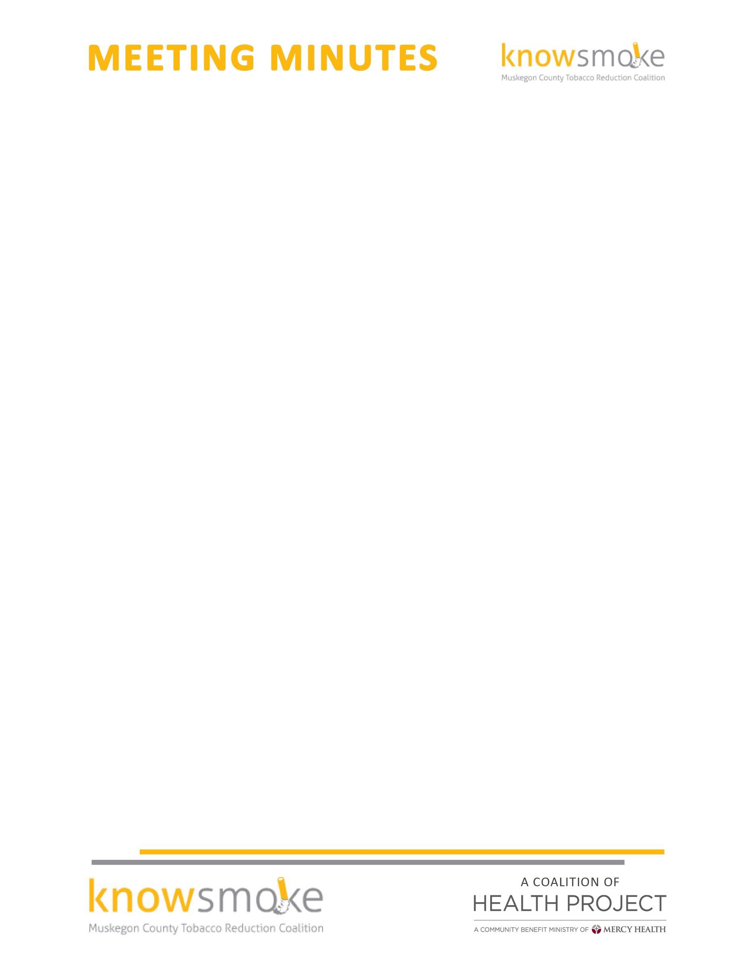

MEETING TITLE: Knowsmoke Coalition
DATE & TIME: February 27, 2017 9:30 a.m. – 11:00 a.m.

ATTENDEES: Cyndi Powers(MCHP); Rachel McCoy(MCHP);Amy Forward(Access Health);Missy Gallegos(Public Health); Melissa Dove(MFC);Laura Fitzpatrick(MCHP);Joy Evans(MFC); Cinti Mwagu(Public Health); Jared Passchier(Norton Shores PE);Alison Rudick(Red Project)

Welcome and Introductions -- Missy called the meeting to order at 9:00
Approval of Minutes -- January minutes were approved by all members

Coalition Collaborative Project- Officer Jared Passchier, from Norton Shores police department, Chair of ALI explained an idea to coalition members about a DFC wide PSA coalition collaborative project to educate the community about alcohol, tobacco and other drugs. The ask for the coalition was to see if Knowsmoke members would be willing to support this initiative. The coalition members were all in agreement. Members asked about the financial contribution that Knowsmoke would have to allocate for this activity. Jared and Laura mentioned that details are still in the works and updates will be provided after more discussion is had and after the strategic planning which takes place during the months of June, July, and August. The idea is to debrief and have conversations based off of the data collected from the strategic planning sessions. The final ask of the coalition members was if they would be in support of this effort and everyone was in agreement. Discussion of involving YAC youth during the strategic planning was discussed.
CADCA Update- Cyndi updated the coalition members on an idea that she gathered at CADCA on a Tobacco Take-Back event. The event consisted of having community members who smoke to drop off their tobacco products including e-cigs and paraphernalia in exchange for free NRTs along with educational material including smoking cessation resources. The group was asked of the community would benefit from an event like this. Some members voiced the idea of partnering with the MAMDP RX take back event. Coalition members agreed that this could benefit the community and Rachel McCoy will be connecting with the chair of MAMDP to see if they would support this efforts and put out a question on their survey for Aprils event to see if the community would like to see a tobacco take back event in Muskegon.
Tobacco 21 Initiative Update- Survey to community – Chamber of commerce is putting out county wide survey and adding a tobacco 21 question. Discussed opinion No. 7294. Also discussed the resolution of support efforts and that the coalition will only be conducting surveys to Businesses, providers, youth and adults and continue to push the resolution of support in the community. Working w/YAC kids on educating their peers on the Tobacco 21 initiative that will be a KBD event on March 8 & March 15. Youth will encourage fellow students to sign banner to use at future T21 education initiatives.

Social Media Committee Update – Rachel McCoy shared with the group that they developed posts that coincided with the Oscars on movies that display tobacco use and how youth can be exposed to tobacco through a PG-13 movies. Displaying messages that may cause youth to believe that this is a norm. Efforts to educate that this is not the norm was the goal of these media posts.

Other good and welfare – Advocacy day was discussed taking place May 1 and 2. The Shoaltion taking place April 25, was also discussed.

Next Meeting: March 27 , 2017 at 9:30am -10:30am The Coffee Factory

