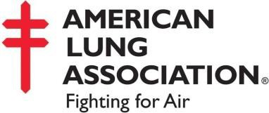
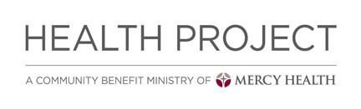
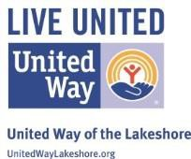
Make this your year to Quit!

LEARN MANAGE STOP
The Freedom From Smoking cessation class can help smokers manage cravings, thoughts, and social relationships to maximize quit rates and remain smoke-free.

Class Details
The more you
TRY the more likely you are to succeed.

Date & Time

4 wk course- 1 hr classes available – between 9:00-12:00
March 19-April 30

Every Tuesday
9:00-12:00
Location:
Access Health
1200 Ransom St
Muskegon, MI 49440

FREE one-on-one
Smoking Cessation
Classes

Cost
FREE-Must call to register

Registration
Contact Cyndi Powers (231) 672-3211 to register

